# ScriptBuddy Documentation

Table of Contents

ScriptBuddy Documentation 1

Introduction 2

Getting Started – Creating an Account and Logging In 2

Main Window – Controls 3

Main Window – Creating and Running a Script 4

Creating the Script 4

Running the Script 5

Main Window – Exporting a Script 6

Uploading and Downloading Community Scripts 6

Uploading 6

Downloading 7

Personal Scripts 8

Changing/ Deleting Your Profile 9

Making Changes 9

Deleting Your Account 10

## Introduction

ScriptBuddy is a Windows application that allows you to create, execute, and export AutoHotkey scripts within one application, without ever having to install AutoHotkey itself or write any code. This enables users who are unfamiliar with writing scripts to generate them with no prior coding experience.

A script is an executable program that allows you to automate repetitive tasks, such as mouse clicks, keyboard inputs, and more. With ScriptBuddy, users can generate scripts to do many of these basic tasks.

## Getting Started – Creating an Account and Logging In

While you do not need to be registered and logged in to use ScriptBuddy, doing so allows you to save your scripts to your personal database and to share scripts with the community. If you would like to create an account, take the following steps:

1. In the main window, select “SIGN IN”

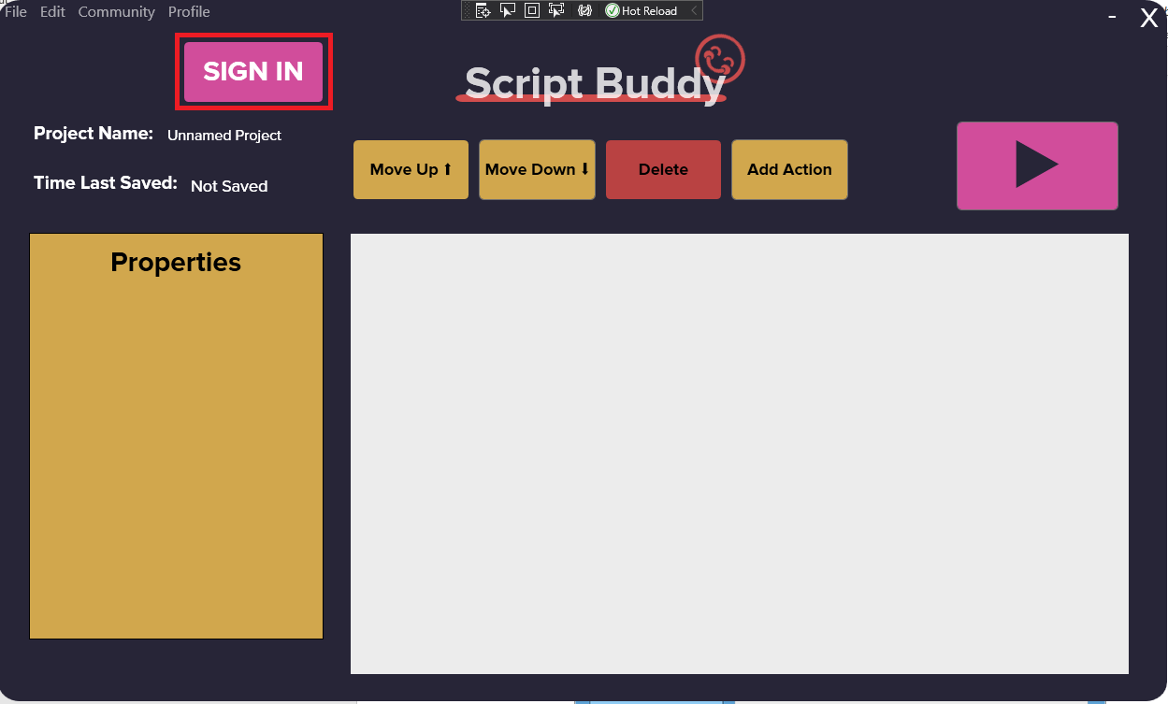

Figure 1: Sign In Button

1. Click “Create Account”
2. Choose a Profile Name, Username, and Password
   1. Profile Name and Username can be the same, but they most both be unique. You may not choose a Profile Name or Username that belongs to any other user.
   2. You must correctly enter your password twice, and the password you choose must be at least 8 characters long.
3. Once the form is filled out, click “Create Account” to finish the process; if your account is successfully created, you will get a confirmation message (*Figure 2*).

Figure 2: Successful user creation

Once you have created an account, you can login at any time under the login screen using your Username and Password.

## Main Window – Controls

The Main Window is where most of the action takes place in ScriptBuddy. Here is a quick run-through of what the buttons on the page do.

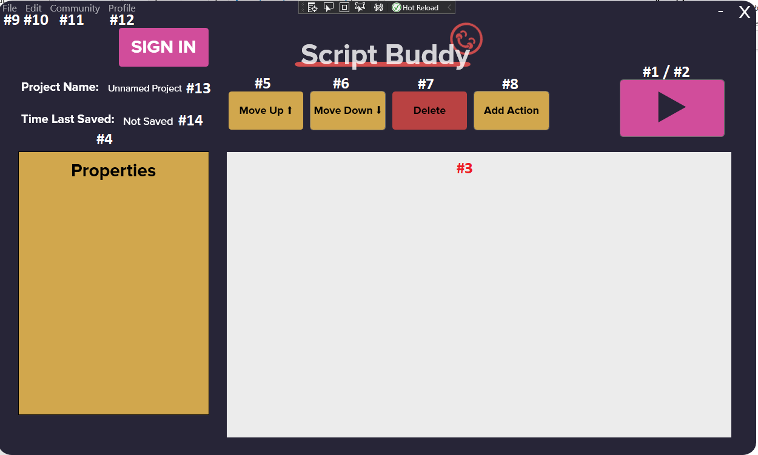

Figure 3: Annotated Main Window

1. **Play button:** Executes the script currently in your viewing window.
2. **Stop button:** Stops script execution.
3. **Viewing window**: List of actions that make up your script that will be executed when your script is running.
4. **Properties:** When an action is selected in the viewing window, it displays the corresponding action properties for editing.
5. **Move up:** Move the selected action in the viewing window above the one directly above it.
6. **Move down:** Move the selected action in the viewing window below the one directly below it.
7. **Delete:** Delete the selected action from the script.
8. **Add action:** Add an action to the script.
9. **File:** File actions that allow you to create a new script, export the current script, or exit the program.
10. **Edit**: Additional edit actions that allow you to undo or redo your most recent change to the current script.
11. **Community:** Access to community scripts.
12. **Profile:** For logged in users, access to profile settings and saved scripts.
13. **Project name:** Current name of script in viewing window.
14. **Time last saved:** Last time the current script was saved to the user’s profile.

## Main Window – Creating and Running a Script

### Creating the Script

Once you have created an account (or not) and familiarized yourself with the environment, you are ready to start creating scripts.

In ScriptBuddy, scripts are made up of **actions** rather than lines of code. There are eight types of actions you can add to your script to execute in any order. If you select “Add action” from the Main Window, you can view the available actions and add them to your working script.

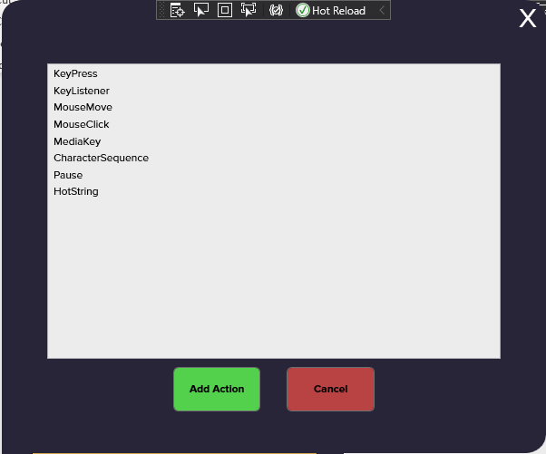

Figure 4: Script actions

1. **KeyPress:** Presses some keyboard key press of your choosing. You can select which key and key press type (press down, release, or click) the script will execute.
2. **KeyListener:** This action acts as an “if” block in the script. When the script is executing and the KeyListener registers a key press of the type you specify, all of the actions specified within the KeyListener block will subsequently execute.
3. **MouseMove:** Moves the mouse position to some X and Y coordinates.
4. **MouseClick:** Clicks the mouse button of your choosing. You can select which mouse button and press type (press down, release, or click) the script will execute.
5. **MediaKey:** Presses some media key of your choosing i.e. play/pause, next, or mute.
6. **CharacterSequence:** Types some sequence of characters (a string) of your choosing.
7. **Pause:** Pauses execution of the script for some X amount of milliseconds.
8. **HotString:** Replaces a given “HotString” with a desired string. For example, if you would like a script that expands the HotString “btw” to “by the way” every time you type it.

Add as many of these actions to the viewing window as you would like. Selecting one of the added actions in the viewing window allows you to move, delete, or edit it in the properties window.

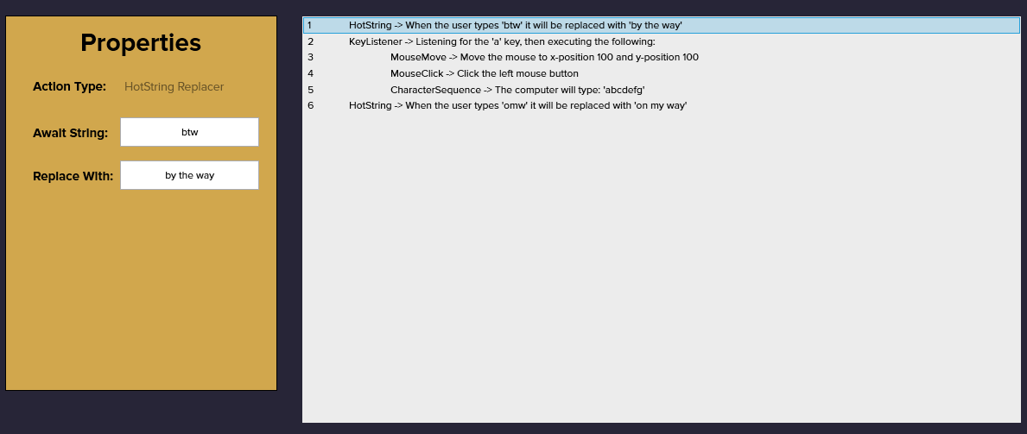

Figure 5: Change the selected action's properties on the left-hand side

Remember, you can always use “Edit” -> “Undo”/”Redo” if you make a mistake!

### Running the Script

When you are ready to execute a script in the background, simply press the Play button, and your script will be executing in the background. Remember to always **press the Stop button before exiting the screen** so your script does not continue executing in the background.



Figure 6: Press play and watch your script at work

## Main Window – Exporting a Script

If you would like to export the script you have created in the Main Window as an AutoHotkey file, simply use “File” -> “Export” to open the File Explorer on your PC. Name the file and select where you would like to export it to, and the AutoHotkey file will be saved locally.

## Uploading and Downloading Community Scripts

### Uploading

ScriptBuddy does not currently support the ability to save and import scripts locally from your PC. However, if you are a registered user, you can upload scripts to your account and view them in your Personal Scripts window (discussed later in the tutorial).

When you have the script you would like to upload ready in the Main Window, select “Community” -> “Upload”. This screen will give you the option to give your script a title, description, and community tag for categorization purposes. Choose if you would like your script to be viewable and downloadable by other ScriptBuddy users or not, then “Upload”.

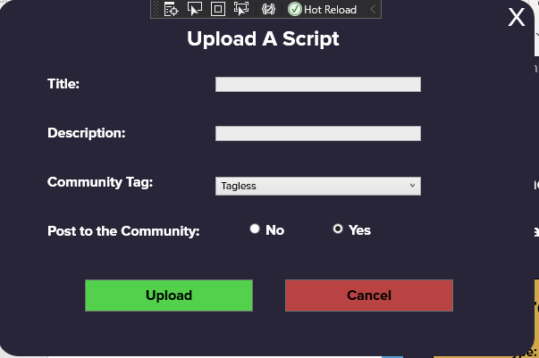

Figure 7: Upload a script

Any script you upload will be visible to you when you are logged in on the Personal Scripts page, but only the scripts you choose to post to the community will be available from the Community Scripts page as well.

### Downloading

Whether you are logged in or not, you can download scripts from the Community Scripts page that yourself and others have posted for public browsing. Access this page from the Main Window “Community” -> “Browse”.

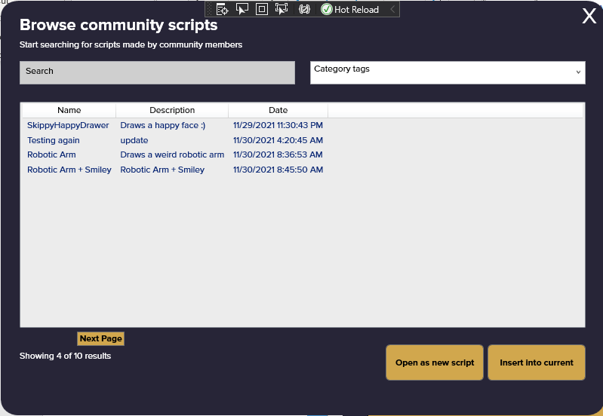

Figure 8: Browse community scripts by title and tag

From here, you can search all public scripts by title and by tag. To use a script, select either “Open as new script” to overwrite whatever is in your Main Window with the community script, or choose “Insert into current” to insert the selected script’s actions into your own script.

**Note:** If you choose to insert a script into your current script, the new actions will be added under the action you had selected when you left the Main Window. If no action was selected, the new actions will be added under **all** the actions you currently have in your script.

## Personal Scripts

While you are logged in, you can view all of the scripts you have uploaded to ScriptBuddy from the Personal Scripts page. Access this page from the Main Window “Profile” -> “View My Scripts”

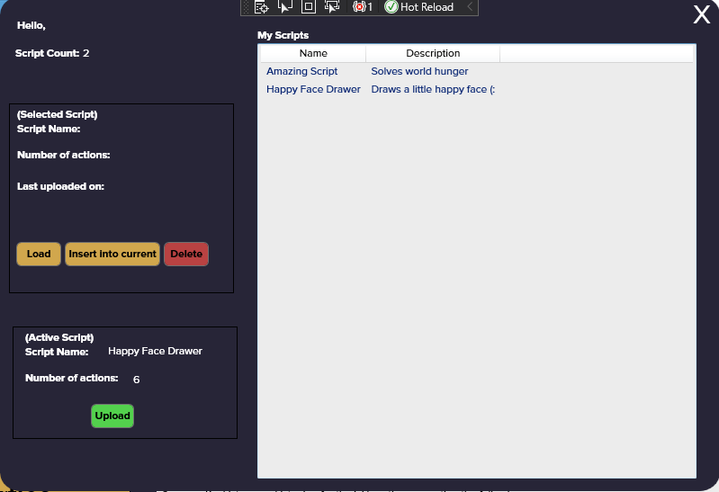

Figure 9: View all of your uploaded scripts

From here, you can see the total number of scripts you have uploaded and a list of every one of them. Selecting a script allows you to “Load” it, overwriting anything you may have in the Main Window, or “Insert into current”, which will insert the actions from it into the current script you have in the Main Window. You can also completely “Delete” the script.

## Changing/ Deleting Your Profile

### Making Changes

If you find yourself needing to make changes to your account, you can do so by selecting “Profile” -> “Settings” from the Main Window while you are logged in.

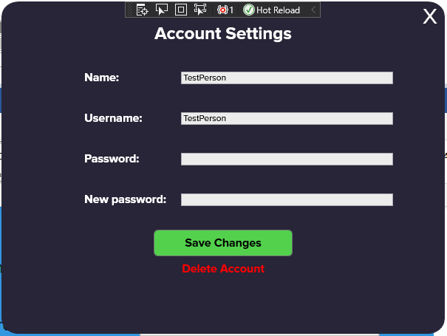

Figure 10: Make changes to your account

From this page, you will see your current Profile Name and Username. Make changes to either of these and then enter your Password into that field to be allowed to “Save Changes”. If you need to, you can also change your password from this page by entering in a “New password”.

### Deleting Your Account

If you want to delete your account, you can start that process by selecting the “Delete Account” option at the bottom of the page. This will take you to a new page to confirm this deletion.

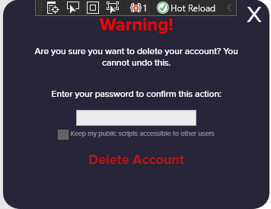

Figure 11: Account deletion process

Make sure you are absolutely certain before you delete your account, as this process is not reversible. Enter your password to confirm the deletion and decide whether you would like your community scripts (if you have any) to stay posted publicly after your account is gone. Once you enter the correct password and press “Delete Account”, you will be removed from the ScriptBuddy database and will no longer be able to login or access any of your uploaded scripts.